1. 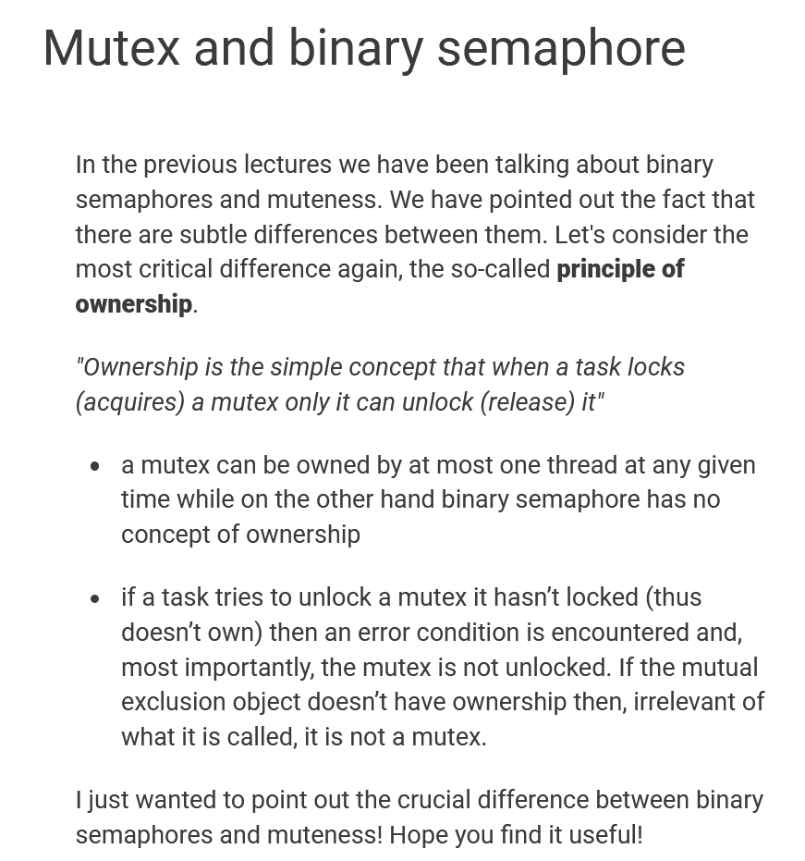
2. **Jatin Semaphore**:
   1. With lock, we can use synchronized keyword on as many methods/blocks as we want to control access by multiple threads but in case of semaphore, we can’t implement such kind of restriction.   
      Actually, if we want to do such with semaphore then we can to create as many semaphores as the no of blocks/methods we want to synchronize.